***Determining the Acceleration of a Dynamics Cart Down***

***an Inclined Plane***

November 15, 2017

SPH3U0-A

Owen Brake – Port Credit Secondary School

Jurisevic, J.

**Background Information:**

This lab summarizes much of the concepts discussed in the kinematics and forces area of physics. The lab uses acceleration, velocity, vectors, gravity, static friction, kinetic friction, inclined planes, trigonometric functions, motion sensors and mass.

Velocity is the change in displacement of an object over a period of time. Velocity is a vector unit and is expressed using the SI unit m/s and the variable v (NIST, n.d.). In this lab the motion sensor analyzes the change in displacement of the dynamics cart to calculate its velocity and the change in velocity is used to determine whether the cart continues to accelerate.

Acceleration is the change in velocity over a period of time. Acceleration is a vector unit that is expressed using the SI unit m/s2and the variable a (NIST, n.d.). In this lab the velocity that is calculated through the motion sensor is used to determine the acceleration of the dynamics cart. Determining the acceleration is pivotal to the lab and is what the hypothesis is attempting to prove.

Vectors are a way of expressing a value with both a magnitude and a direction. Vectors are used to express mathematical values in multi-dimensional spaces since scalar units are limited to the first dimension. Vector units are units that are represented with both a magnitude and a direction for example velocity, acceleration, displacement and force. In this lab vector units are used to calculate acceleration and velocity in a two dimensional plane.

Gravity is a force that pulls two objects that contain mass towards each other. Gravity is a vector unit since it is a type of force and it uses the SI unit of N and the variable of g (NIST, n.d.). The force of gravity between the planet earth and an object can be assumed to be 9.8m/s2 (Holzner, n.d.) however it changes slightly based on longitude, latitude, altitude and local geology (Rothstein, 2016). For this experiment gravity is used to pull the dynamics cart down the inclined plane, if there were no gravity then the dynamics cart would not have the force that pulls the cart down the ramp. If the gravity of the planet it is tested on were different then the dynamics cart would pulled down the ramp at a different acceleration due to ­the force having a greater or lesser magnitude.

Static friction is the force of friction that is caused when an object is at rest or attempting to leave rest. Kinetic friction is the force of friction that affects objects that are in motion. Static and kinetic friction are forces so thus they are vector quantities with an SI unit of N (NIST, n.d.). Static friction is represented as FS and kinetic friction is represented as FK The coefficient of static friction tends to be higher than the coefficient of kinetic friction so thus the force required to move an object at rest is greater than moving an object in motion. In this lab friction is important to understand the different observations and calculations made. With varying coefficients of friction comes varying results. If there were to be a higher force of kinetic friction then the dynamics cart would accelerate less or possibly deaccelerate, if a lower force of kinetic friction then the dynamics cart would accelerate more.

Inclined planes are flat surfaces that are tilted at an angle. Inclined planes are used to move objects up or down without the use of complex mechanisms. When a surface has a flat incline then it will form an abstract triangle. This triangle can be used to calculate the many things an experiment may need to find for example, by using trigonometric functions to find the angles with the lengths of the boards and by determining all the forces acting upon it using vectors. In this lab the ramp is an example of inclined planes, the dynamics cart is moved down to a lower surface by sliding the dynamics cart down the surface.

Trigonometric functions are the functions used to determine the relationship between the sides of a triangle with its angles. Trigonometric functions are most commonly used as sinθ = opposite/hypotenuse, cosθ = adjacent/hypotenuse and tanθ = opposite/adjacent. These functions are the foundations of trigonometry and are fundamental to solving any problems that involve triangles. In the lab it is necessary to calculate the angle of the ramp, so to do this the experimenter must use these functions to calculate the angle of incline or decline for the triangle.

A motion sensor is a device that detects the position of objects in motion. There are different ways that motion sensors can gather this information. The main methods are Passive Infrared, Ultrasonic, Microwave and Tomographic (Agarwal, n.d.). The sensor used in the lab is the Vernier motion detector. The Vernier motion detector is an ultrasound sensor so it works by sending out ultrasound waves, the motion sensor then waits for the signal to reflect back and determines the distance by analyzing the wave as can be seen in Figure 1. (Motion Detector User Manual, n.d.). The Vernier motion sensor is used in the lab to determine the position of the cart at a certain time and then processes it to send to the computer.

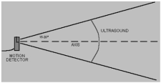

Figure 1 Diagram of how the Vernier Motion Detector manipulates ultrasonic waves. Retrieved from (Motion Detector User Manual, n.d.).

Mass the amount of matter that an object is made up of. Mass is commonly represented with the variable m and uses the SI unit of kg (NIST, n.d.). Mass is a scalar quantity and is often interchanged with the concept of weight which is the amount of gravity acting on an object. Mass is used in many formula because it is the basis of converting an acceleration into a force, the most common equation in Newtonian physics that uses mass is the formula F=ma which converts a mass and acceleration to a force. In this lab the mass is important because it dictates the friction force and gravitational force acting upon the objects. If the mass is too large that it creates a significant friction force using the formula FF=μF­N then the object may not move.

**Hypothesis:**

If a dynamics cart is placed on a ramp with an incline of 8.5o or less than the cart will

not reach terminal velocity for at least one metre. US

**Materials:** dynamics cart, Vernier motion sensor, 1.22m long plane of wood, metre stick, computer with logger pro. USB cable

122cm

18cm

120.6cm

Figure 2 Diagram of the ramp and its dimensions

**Procedure**

1. The ramp of 122 cm is placed so that it inclines to a height of 18 cm as demonstrated in Figure 2.
2. The Vernier motion sensor is set to cart mode as demonstrated in Figure 3.
3. The Vernier motion sensor is placed at the top of the ramp so that the gold foil pieces face down the ramp

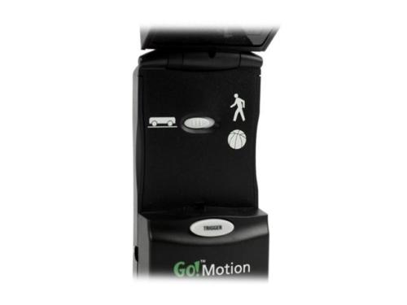

Figure 3 The Vernier motion sensor set on cart mode.

1. The Vernier motion sensor is connected to the USB port of the computer using the USB cable
2. Logger pro is launched on the computer
3. The Vernier motion sensor trigger button is pressed
4. The dynamics cart is held at the top of the ramp, just against the motion sensor
5. The dynamics cart is let go and the collect button on Logger pro is pressed
6. After the dynamics cart has departed from the ramp the collect button is clicked again to stop recording results
7. The x and y axis are altered to fit all the relevant data

**Observations**

|  |  |  |
| --- | --- | --- |
| Time (s) | Position (m) | Velocity (m/s) |
| 0.1 | 0.183 | 0.489 |
| 0.2 | 0.241 | 0.624 |
| 0.3 | 0.308 | 0.736 |
| 0.4 | 0.388 | 0.851 |
| 0.5 | 0.478 | 0.964 |
| 0.6 | 0.582 | 1.088 |
| 0.7 | 0.695 | 1.203 |
| 0.8 | 0.821 | 1.289 |
| 0.9 | 0.956 | 1.274 |

Table 1. The measured time, position and velocity of the dynamics cart as it accelerates down the ramp.

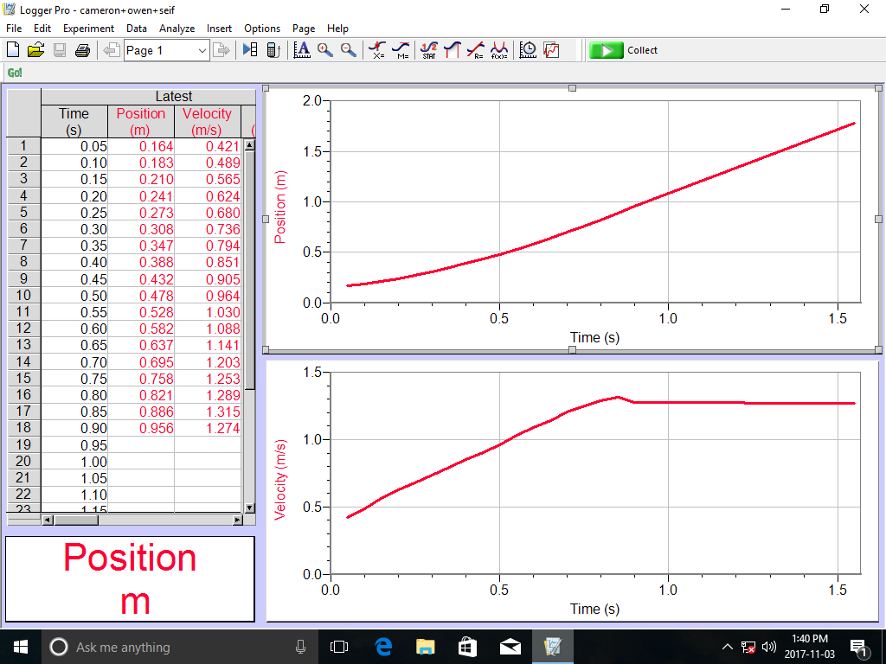

Figure 4. The position-time and velocity-time graph of the dynamics cart as it accelerates.

|  |  |  |  |
| --- | --- | --- | --- |
| Time (s) | Velocity (m/s) | Equation () | Acceleration (m/s2) |
| 0.1 | 0.489 | (0.489m/s - 0m/s) / (0.1s - 0.0s) | 4.89m/s2 |
| 0.2 | 0.624 | (0.624m/s – 0.489m/s) / (0.2s - 0.1s) | 1.35m/s2 |
| 0.3 | 0.736 | (0.736m/s – 0.624m/s) / (0.3s – 0.2s) | 1.12m/s2 |
| 0.4 | 0.851 | (0.851m/s – 0.736m/s) / (0.4s – 0.3s) | 1.15m/s2 |
| 0.5 | 0.964 | (0.964m/s – 0.851m/s) / (0.5s – 0.4s) | 1.13m/s2 |
| 0.6 | 1.088 | (1.088m/s – 0.964m/s) / (0.6s – 0.5s) | 1.24m/s2 |
| 0.7 | 1.203 | (1.203m/s – 1.088m/s) / (0.7s – 0.6s) | 1.15m/s2 |
| 0.8 | 1.289 | (1.289m/s – 1.203m/s) / (0.8s – 0.7s) | 0.86m/s2 |
| 0.9 | 1.274 | (1.274m/s – 1.289m/s) / (0.9s – 0.8s) | -0.15m/s2 |

Table 2 The measured time and velocity for the dynamics cart and the calculated acceleration.

**Calculations**

122cm

18cm

121 cm

Figure 5 Diagram of the ramp and its dimensions

θ

https://latex.codecogs.com/gif.latex?hypotenuse%20%3D%201.22m

https://latex.codecogs.com/gif.latex?opposite%20%3D%200.18m

https://latex.codecogs.com/gif.latex?sin%5CTheta%20%3D%20%5Cfrac%7B18%7D%7B122%7D

https://latex.codecogs.com/gif.latex?%5CTheta%20%3D%20sin%280.1475%29%5E%7B-1%7D

https://latex.codecogs.com/gif.latex?%5CTheta%20%3D%208.5%5E%7B%5Ccirc%7D

https://latex.codecogs.com/gif.latex?%5Ctherefore%20The%5C%20angle%5C%20of%5C%20incline%5C%20for%5C%20the%5C%20ramp%5C%20is%5C%208.5%5E%7B%5Ccirc%7D%5C%5C

**Sources of Error**

One possible source of error is that of the type of material and the type of wood. Different materials possess different coefficients of friction. If the experiment is attempted again with a different type of wood the results would change. If the type of wood had a smaller coefficient of friction then the dynamics cart would have a less friction force and therefore a higher acceleration. If the type of wood had a larger coefficient of friction than the cart would have a higher friction force which would mean that the acceleration would be lesser. The friction force would be changed because of the equation FF=μF­N**,** the friction force in this equation is directly proportional to the normal force and the coefficient of friction. This is an example of systematic error because by attempting this experiment multiple times with the same material would result in similar results but by changing the material the results would be different. To solve this issue the material list should reference a specific brand of ramps, by having a vague definition of a ramp it creates this error so there should be an established ramp that is used for all experiments.

Many of the dynamics cart that were used in other experiments were observed to have inconsistencies in design compared to the one used in this experiment. Some dynamics carts had four wheels while others had four wheels, if there were only 3 wheels compared to the standard four the dynamics cart would have a different balance or lean so it would potentially not fall down the ramp straight, which would change the change in position and acceleration of the cart. Some carts had axles that were looser than others, this would mean that the cart would wobble and the wheels would have less contact with the ground causing the cart to have a lower acceleration. These inconsistencies with the carts are examples of systematic errors because the error is caused by the instrument and can be accounted for in the observations, there would be a fairly constant difference in the results if the two carts were different. To solve this there should be a specific dynamics cart model or setup that should be referenced so that the inconsistencies within the carts are minimized for future attempts.

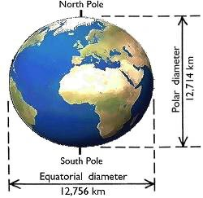

Figure 6 A diagram of the earth representing its non-spherical shape

The setting of the lab affects the experiment due to the planet’s inconsistent force of gravity. Gravity can be affected by multiple things including the latitude and altitude (Rothstein, 2016). If the experiment were performed at a lower latitude potentially at the equator then the results would contain an acceleration that is slightly lower, this is due to the fact that the earth rather than being perfectly round it is actually an oblate spheroid a shape similar to a sphere but appears to be compressed vertically as can be seen in Figure 6. (Masters, 2002). Since the distance to the center of the earth from the equator is greater than from the poles, gravity will exert less of a force onto the object at the equator than closer to the poles. Altitude also affects this for the same reason, if the experiment is performed at a high altitude then the force exerted onto the object is less due to the distance from the object to the planet is greater which means the acceleration will be lesser. This is a form of systematic error because this can be accounted for in the calculations and can be repeated, if someone were to perform the experiment in the same place they would get the same result but if they went somewhere else they may get a different result. To correct this the experiment should be performed in the same setting however this is usually infeasible so future experimenters may have to account for this change in gravitational force and explain why the results are not perfectly accurate but mention that the experiment was performed with reasonable error.

The stability of the board could have caused issues when running the experiment. The material list does not include any device to ensure the board remains straight. Since there was no device ensuring the stability the board was shaking due to the movement of the dynamics cart and due to external forces. The shaking of the board would have caused a force reacting back onto the dynamics cart affecting its acceleration, the board could have moved horizontally causing the cart to move irregularly or the shaking of the board could have affected the sensor. This would be a random error because the magnitude and effect of this instability would be immensely difficult to measure due to the randomness of external forces that could be affecting it including but not limited to the steps of other experimenters, a change in direction or magnitude of wind and the shaking due to the movement of large automobiles or trains. This type of error can be minimized but extremely difficult to solve. The easiest and most effective way to minimize this error is to include devices in the materials list that maintain the stability of the board including clamps or vices. However these mechanisms cannot solve this issue because even if they do minimize the effect dramatically it does not solve this issue, to do this the dynamics cart would have to be placed in a vacuum room with no movement because even small movements can affect the experiment. Most likely however a clamp mechanism would suffice and minimize the error to within the precision of the measurements.

**Analysis**

The results are fairly reasonable within the context of the experiment. Since the ramp declines at a constant angle there should be a constant acceleration where the acceleration is always the same. The values between 0.2 seconds and 0.7 seconds share a consistent acceleration only diverging by approximately 0.23 m/s2 a value that can be assumed to be a combination of statistical noise, the concept that the universe is imperfect and through one of the sources of error.

There is one major issue though, the values of acceleration at 0.1, 0.8 and 0.9 seconds. These values are values that differ heavily from the rest of the data. The value at 0.1 seconds has a very significant acceleration compared to the rest of the values. The dynamics cart was not accelerating at a rate of 4.89 m/s2 this is due to a combination of instrument and human error. According to the Vernier website the motion sensor has a minimum range of 0.15m, this is consistent with the data which reveals that the cart began at 0.183m (Motion Detector User Manual, n.d.). The reason the cart supposedly started at 0.183m is because the sensor only started recording the cart after 0.15m. The heightened acceleration is caused due to the assumptions made when finding the acceleration using the slope of the line method. When using the slope of the line method it was assumed that at 0 seconds the distance from the sensor would be 0 metres however we know this is not true because the sensor does not receive data until the cart is passed 0.15m, so it believes that the time for the cart to go from 0 to 0.183 metres is 1 second. There is also the human element however it is possible that when dropping the cart and clicking the button on Logger pro the experimenter did so at different times. Since the experiment deals with such precise measurements fractions of a second count so human reaction time can play a large factor. The issue at 0.8 and 0.9 seconds however is not due to error it is a part of the experiment. The reason that at 0.8 seconds there is a significant drop in velocity is because the dynamics cart left the ramp, once the cart left the ramp it was stopped by one of the participants at the bottom of the ramp. Since the participant stopped the cart it meant that the cart travelled a lesser distance over the same amount of time resulting in a lower acceleration and change in velocity. The reason that 0.9 seconds has a negative value is due to Newton’s third law. Newton’s third law says that “For every action, there is an equal and opposite reaction” (Lucas, 2017) this means that when an object pushes onto another object is gets pushed back with an equal force. When the cart hits the experimenter’s hands at the bottom of the ramp a force is applied backwards which mean that it will move or accelerate backwards slightly. Despite the apparent inconsistencies and issues in the data, the data is reasonable and can be justified as appropriate measurements.

**Conclusion**

The dynamics cart does not reach terminal velocity when descending upon a one metre ramp with an incline of 8.5o.The observations and calculations have been interpreted to determine that the hypothesis was correct. It was found that the dynamics cart continues to accelerate and does not reach a point with a zero acceleration. Since there was an acceleration throughout the data it has been found that the dynamics cart did not reach terminal velocity within the one metre distance, proving the hypothesis.

**Applications**

Ramps are used throughout society and have created the foundation for modern technology. A ramp is another term for an inclined plane which is a surface that is inclined at an angle. The reason that ramps are so prevalent in modern society is due to their efficiency, pushing an object on a ramp requires less force because the force is distributed along larger distance, so it requires a greater distance to move but a lesser force. The steeper the slope the more force required however if it is more flat than it has to travel a longer distance. Some examples of inclined planes are ramps on to freeways, roofs, the ski lift magic carpet and the transport of goods.

One example of a ramp is a highway on or off ramp. These ramps exist on major highways to allow cars to enter and merge in an inexpensive, safe and efficient manner. These ramps are used on many freeways throughout Ontario including on Highway 404 and Highway 7. (O'Reilly, 2016) The ramps work by having an inclined plane that connect with a highway, adding an extra lane until the incoming traffic has enough time to merge into the rest of the traffic. By having these ramps it allows the traffic to merge rather than stopping the traffic to allow the incoming traffic to enter, this allows the traffic to flow faster and more smoothly. The ramps also allow the cars to reach a higher level onto the freeway a feat which would be ineffective with any other mechanism. Using a ramp to enter a highway is smart because cars require a horizontal surface to move along they cannot climb and a ramp for the highway makes it so the car has to use less force to enter onto the highway. The use of these ramps on highways is quite similar to the way the ramp was used in this experiment. The ramp in the lab was used to transport the cart from the top of the ramp down to the bottom, exactly what an off ramp in a highway would do. The difference between the experiment and the real world is simply scale, all the same mechanics exist in the experiment on the freeway just on a larger scale.

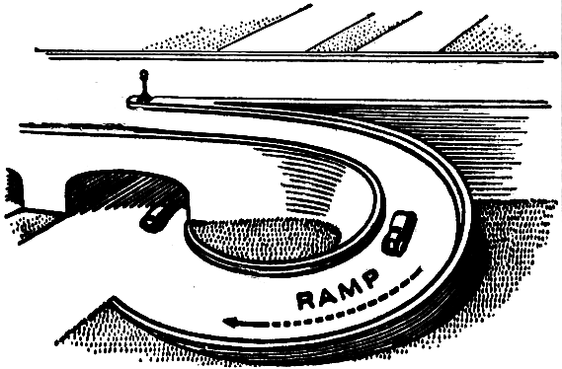

Figure 7. A highway on-ramp.

Another example of a ramp in modern society is the roof. The average roof on a house has a triangular prism shape where on either side of the house there is a slanted plane. This has historically existed so that rain when it would fall would slide off the edge of the house preventing rain from breaking the roof. It has also been used because a triangle is the strongest shape so to provide better structural integrity the triangle would be put in. In modern society however this is not true, modern technology and material can be used to prevent this danger caused by rain that is why businesses, schools and apartment buildings have a flat roof, there is not concern about structural integrity and it is economically better to have a flat roof. The reason houses still have these roofs is because it is seen as necessary and normal to society for roofs to be triangular shaped (Brady, 2013). Like the dynamic cart in the experiment the rain accelerates down the incline until it reaches the end point in which it falls off of the ramp.

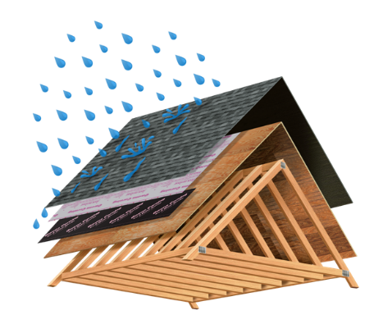

Figure 8 Diagram of how an angled roof is supposed to work.

When beginners or young children begin to learn to ski they often will experience the magic carpet. The mechanism works by having a conveyor belt which is constantly turning this mat. The participants will walk up to the designated area and stand onto the moving mat. While on the mat the participant will be pulled up the hill until it is necessary for them to step out and depart from the lift. Previously there was no surface underneath the rider besides the snow so one was simply dragged up the hill with a bar, this sparked safety concerns and it was revealed that it was difficult for beginner to use (Wold, 2010). Now the company magic carpet has a product where there is a conveyer belt underneath the skis of the transported. By having the product run under the person’s feet it prevents peoples’ skis from becoming crooked and it makes it a lot easier to ride since the feet and hands are moving at the same speed. This is very similar to the lab however in the lab the force of gravity causes the cart to descend the plane while in the ski lift the conveyer belt pulls the participant up the hill against the force of gravity.

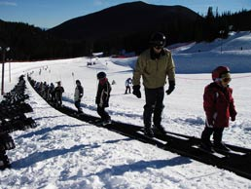

Figure 9 A Magic Carpet Ski Lift

Transporting good with an inclined plane is a necessary and important task. Attempting to transport goods without an inclined plane would be difficult and nearly impossible. A ramp is an efficient method for transporting things because it requires less force then directly lifting goods, since the force is spread out over a large surface. It is also safer to use a ramp over lifting an object, by lifting an object that is heavy it poses a risk to one’s bone structure and feet (Lampton, 2008). If a large object were to fall no a participants foot it could cause severe damage however with a ramp this is avoided because the object never leaves a flat surface so can no longer fall. This also affects bone structure because all that heavy lifting creates stress on one spine, a severe amount of stress on the spine can cause serious damage. By having this inclined plane, heavy objects can be moved without expensive equipment and with a lesser force. Transporting goods with an inclined plane can be used for many things including military helicopters, transport trucks and loading auto carriers. This example is similar to the lab but is simply reversed. In the lab an object was moved down the ramp using the force of gravity however when transporting goods the object is moved up the incline and works against the gravity force.

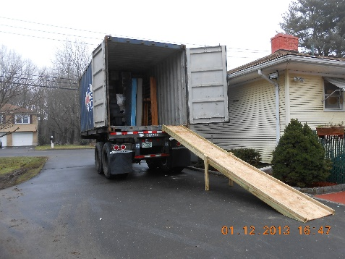

Figure 10. A transport truck with a ramp

# References

Agarwal, T. (n.d.). *What are Motion Sensors And How Do They Work*. Retrieved from ELPROCUS: https://www.elprocus.com/working-of-different-types-of-motion-sensors/

Brady, A. (2013, June 15). *Ask a grown-up: houses have pitched roofs, so why don't office blocks and schools have them?* Retrieved from The Guardian: https://www.theguardian.com/lifeandstyle/2013/jun/15/ask-grown-up-roofs-architecture

Holzner, S. (n.d.). *HOW TO CALCULATE THE FORCE OF GRAVITY ON THE EARTH’S SURFACE*. Retrieved from Dummies.com: http://www.dummies.com/education/science/physics/how-to-calculate-the-force-of-gravity-on-the-earths-surface/

Lampton, C. (2008, October 28). *How Loading Ramps Work*. Retrieved from How Stuff Works: https://auto.howstuffworks.com/auto-parts/towing/equipment/accessories/loading-ramps.htm

Lucas, J. (2017, September 5). *Equal & Opposite Reactions: Newton's Third Law of Motion*. Retrieved from LiveScience: https://www.livescience.com/46561-newton-third-law.html

Masters, K. (2002, October 2). *Does your weight change between the poles and the equator?* Retrieved from Ask an Astronomer: http://curious.astro.cornell.edu/our-solar-system/the-earth/42-our-solar-system/the-earth/gravity/94-does-your-weight-change-between-the-poles-and-the-equator-intermediate

*Motion Detector User Manual*. (n.d.). Retrieved from Vernier: https://www.vernier.com/manuals/md-btd/#section8

NIST. (n.d.). *International System of Units*. Retrieved from The NIST Reference on Constants, Units and Uncertainty: https://physics.nist.gov/cuu/Units/units.html

O'Reilly, D. (2016, August 29). *Transforming the Highway 404/Highway 7 interchange*. Retrieved from Daily Commercial News: http://dailycommercialnews.com/Infrastructure/News/2016/8/Transforming-the-Highway-404Highway-7-interchange-1018122W/

Rothstein, D. (2016, January 30). *Does gravity vary across the surface of the Earth? (Intermediate)*. Retrieved from Ask an Astronomer: http://curious.astro.cornell.edu/about-us/42-our-solar-system/the-earth/gravity/93-does-gravity-vary-across-the-surface-of-the-earth-intermediate

Tchir, J. (2016, January 12). *What is the actual speed limit on a highway ramp?* Retrieved from The Globe and Mail: https://beta.theglobeandmail.com/globe-drive/culture/commuting/how-fast-can-i-ramp-up-the-speed/article28124401/?ref=http://www.theglobeandmail.com&

Wold, R. (2010, October 3). *Denver’s Magic Carpet, maker of ski lifts, takes off*. Retrieved from The Denver Post: http://www.denverpost.com/2010/10/03/denvers-magic-carpet-maker-of-ski-lifts-takes-off/